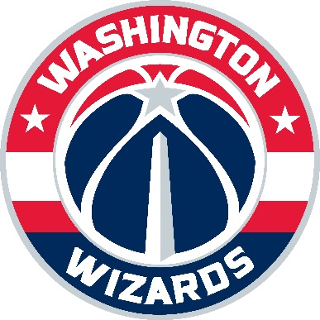

May 14, 2018

Dear Ky,
It was a pleasure to partner with Blueprint Global Group, 100 Black Men of America and all of the corporate partners and supporters of The Made Man. We thank you again for the opportunity to participate in such an honorable event and especially for recognizing Markieff Morris of the Washington Wizards as a 2017 Made Man honoree. We have cultivated many long-standing relationships and look forward to continue building relationships with your partners and supporting you in your continued efforts to engage with the DC community.

Sincerely,
Erin Mitchell Martin
Director, Group Ticket Sales
Washington Wizards

