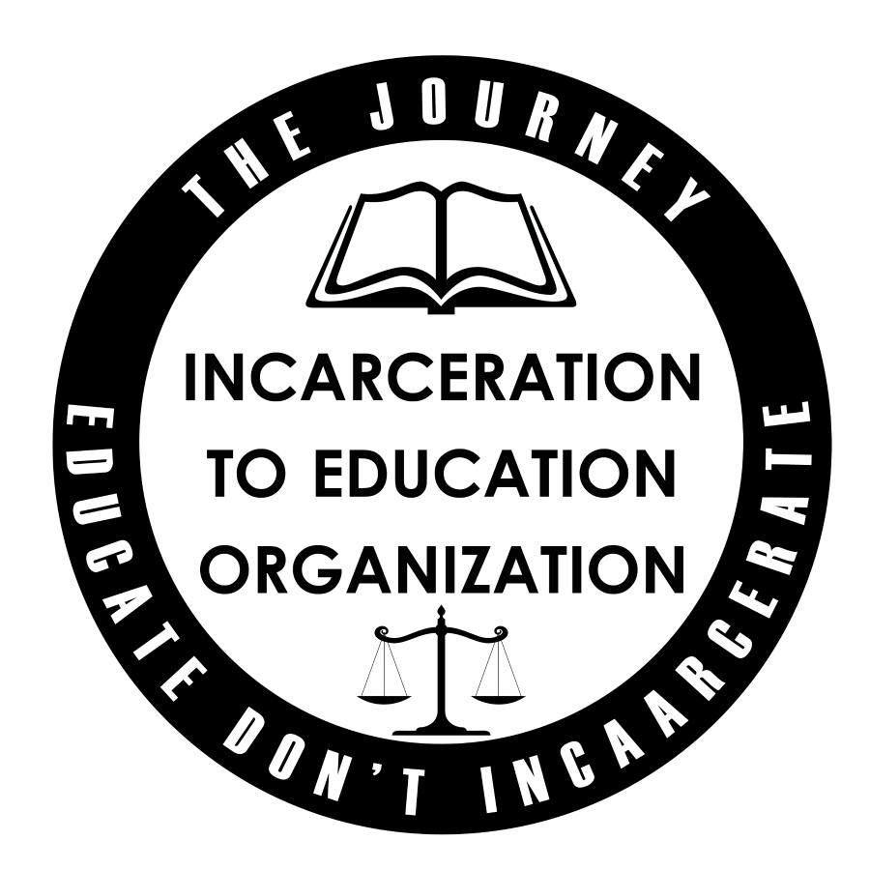
June 26th, 2019
Educate Don’t Incarcerate, LLC
146 West 127th St.
New York, NY 10027

Dear Made Man Foundation,

On Behalf of Educate Don’t Incarcerate, LLC I would like to thank the Made Man Foundation for this year’s recognition as a 2019 Honoree as a Distinguished Leader and Advocate for Change. This recognition, as well as the work of The Made Man Foundation speaks volumes of your commitment to underrepresented communities in the U.S.. Thank you for your on-going work in recognizing leadership within our communities.

The mission of TMM is to highlight the successes of African American men in an effort to empower young men and communities of color. As an honoree I must admit that this experience empowered me.

The call to action to this year’s honorees was not only directed to the communities we serve, but also to one another. This moment not only caused me to make a committed effort in the work we do here at EDI, but also inspired me to focus my attention on the men who were being honored as well. EDI has committed itself to working with other honorees, such Samson styles, creator of Killing Beef . Since the Honoree ceremony, Mr. Styles and I have made a concerted effort to support one another in our work. In fact I will be attending a screening tonight in these efforts.

Again, thank you for your work and commitment in lifting up our communities, but also your passion and commitment in encouraging us to do the same for one another.

Sincerely,

Terrance Coffie,
Founder, Educate Don’t Incarcerate

