December 12, 2018

Hi Dee
Thank you and Ky for having the Made Man Event here in Charlotte. I thought that everything was first class and I enjoyed being honored with the rest of the men in Charlotte. The mentoring session was impactful to the young men we spoke to, but we took away a lot from the sessions also.
The impact your program made in it’s first year was substantial and I know the new crop of men next year will enjoy and appreciate this worthwhile experience as I have.
Thank you again for the honor.

Best Regards,

Charles Whitfield
Integrated Marketing Group
Business Development
Beasley Media Group, Inc.
1520 South Blvd.
Suite 300
Charlotte, N.C. 28203

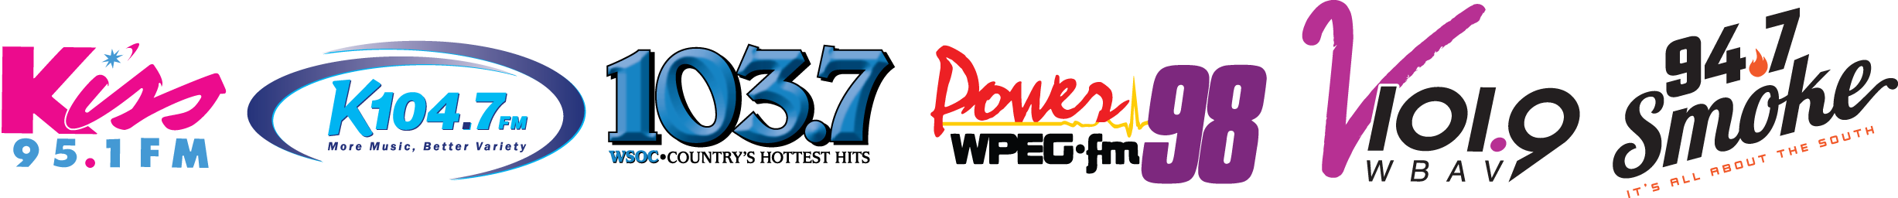
1520 South Blvd. | Suite 300 Charlotte, NC 28203 | 704-522-1103

